Messy Church at home: Week 2 – The Jesse tree
The Jesse tree
The Tree of Jesse is a depiction in art of the ancestors of Christ, shown in a tree which rises from Jesse of Bethlehem, the father of King David. We can make this at Easter time and use egg-shaped or cross-shaped cards to draw our pictures on. (see the second worksheet)
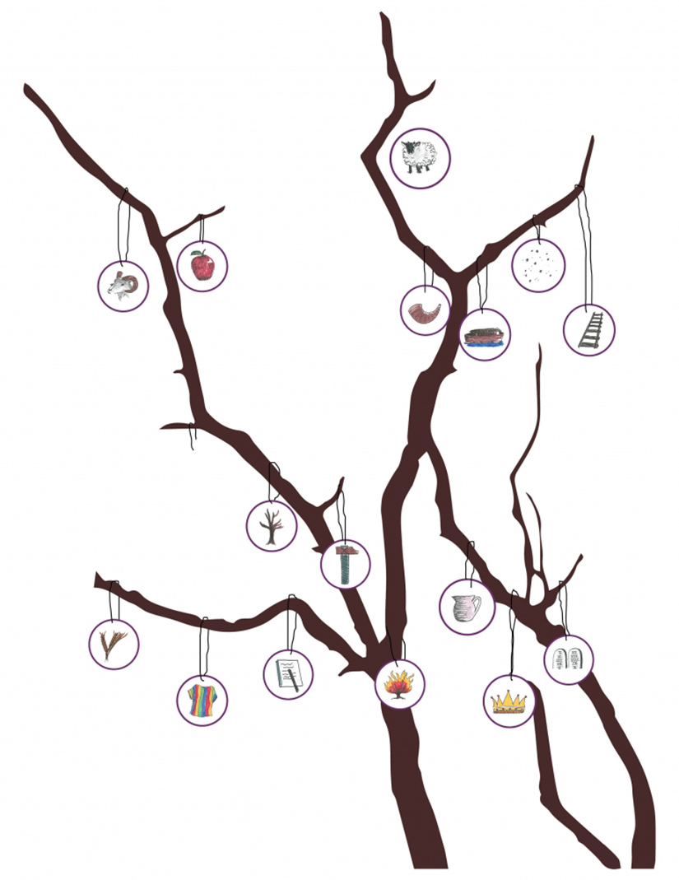

Look in your children’s bible. Draw pictures of things that remind you of the stories, cut them out and hang them onto a twiggy branch. You could use it to do a quiz for your family; can they guess which character your picture represents? What is his/her story?

