Opportunities for Weekday Prayer
In the United Benefice.
MAY 2021

Tuesdays – 9.30am Morning Prayer at HALES fortnightly – 4th, 18th May
Wednesdays – 9.30am Morning Prayer at HINSTOCK fortnightly – 5th, 19th May
-9.30am Morning Prayer at SAMBROOK fortnightly – 12th, 26th May
- 5.00pm Evening Prayer at Cheswardine weekly
Thursdays – 9.30am Morning Prayer at CHILDS ERCALL fortnightly in church – 13th, 27th May
fortnightly by Zoom – 6th, 20th May*
*please e-mail Rev Becky for the Zoom link: beckyrichards@hotmail.co.uk

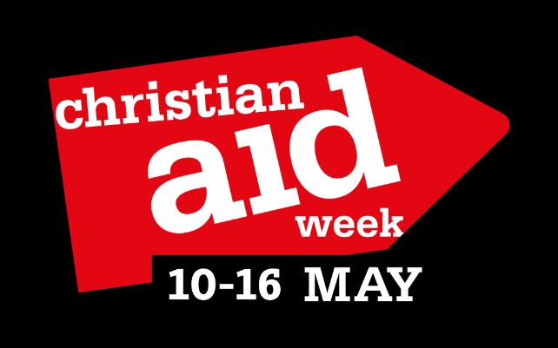

Giving Thanks for our Vaccines

This year as a Benefice we have decided to give to the Christian Aid appeal to ensure that vaccination and P.P.E. reach the poorest countries in our world. You can donate on-line via the page set-up on the Lichfield Diocesan Website. We will set up a link from our own website.
If you prefer to give in cash – please bring this to a Church service this month and we will ensure there are Gift Aid envelopes available.

